A REPORT
ON

AWARENESS PROGRAME

ON
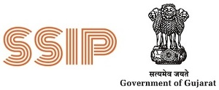
STUDENT STARTUP AND INNOVATION POLICY (SSIP)-2.0

CONDUCTED BY

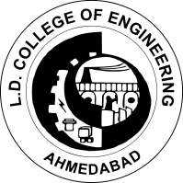
PLASTIC TECHNOLOGY DEPARTMENT
L.D COLLEGE OF ENGINEERING- AHMEDABAD-15

22 September 2022

DEPARTMENT OF PLASTIC TECHNOLOGY
L. D COLLEGE OF ENGINEERING-AHMEDABAD

1 | Name of session/ seminar: | Awareness program on “STUDENT STARTUP AND INNOVATION POLICY (SSIP)-2.0 ”
2  3  4 | Date :  Time:  Venue of the session/Program | 22/09/2022  3:30 pm to 4:30 pm  Room No -721  Smart Class Room, Block 7
4 | No. of participants : | 32 Students
5 | Name of Coordinator | Hetal C. Shah  Assistant Professor  Plastic Technology Department
6 | Photographs of session : | Attached

